Chapter 11, Solution 44.

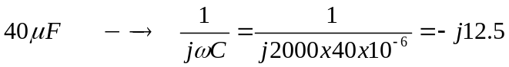

We apply nodal analysis to the circuit shown below.

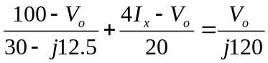
But 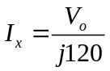. Solving for V_{o} leads to

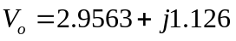

I_{o} 30 Ω -j12.5 20 Ω
V_{o}
+
–
+
–
I_{x}

100∠0º j120 4I_{x}

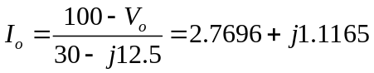

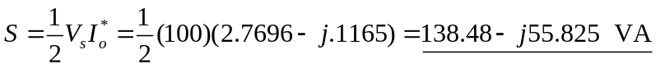

S = (138.48 – j55.82) VA

